

ADMAS UNIVERSITY

School of Post Graduate

Department of Computer Science

Project on Object Oriented Software Development

Project Title: Software Testing and Implementation Document on Auto Bridge

**Group Members**:

1. Abebaw Dagnaw
2. Tariku Kuma
3. Lidet Ketema
4. Bezakulu Mussie

**Submitted to:**

Abdi Mulatu (Associate Professor)

Course number: CS 663

Submission Date: March 14,2021

Table of Contents

1.Introduction 1

1.1Objective 1

2.0 Relationship to other Documents 1

2.1 Software Requirement Document 1

2.1.1 Functional Requirements 1

2.1.2 Non-Functional Requirements 2

2.2 Software Design Document 2

2.2.1 Performance 2

2.2.2 Dependability 2

3.0 features to be Tested 3

3.1 Functional Test 3

3.2 Authentication 4

3.3 searching Dealers result 4

3.4 Spare part Searching result 5

4.0 Features not to be tested 6

4.1 Deployment 6

4.2 Stress handling 7

5 Testing Strategy 7

6 Test case specification 7

6.1 Dealers registration test case 7

6.2 Dealers login test case 8

6.3 users searching of item test case 8

# 

# 1.Introduction

This test plan document describes all the tests we have made on auto bridge platform. This includes dealers registration, dealers login, users search and other data insertion and dealation tests.

It explains the relationship between other documents like SRS and SDD. It also explains the features to be tested and those which cannot be tested along with the reasons why not it is possible to test that particular feature.

And we have attached sample results of the tests and test cases of the platform.

Throughout the testing process we will be applying the documentation specification of described in the IEEE standard 829-1983 format.

## 1.1Objective

The objective of the test plan is to define the various Testing strategies and testing tools used for complete testing life cycle of this project.

# 2.0 Relationship to other Documents

## 2.1 Software Requirement Document

### 2.1.1 Functional Requirements

*The functional requirements for a system describe what the system should do. These requirements depend on the type of software being developed, the expected users of the software and the general approach taken by the organization when writing requirements :(* *sommer vile 10th edition****)***

*The functional requirements are:*

*The system shall display the spare part with year of make*

*The system shall display the model*

*The system shall display where the spare part is manufactured*

*The system shall display who the dealer is*

*The system shall display the price of the material*

In the software requirement document we have listed the above requirements to be fulfilled by the platform. In the final test of the platform, we managed to get our requirement set in the requirement document.

### 2.1.2 Non-Functional Requirements

*The system shall be available for use as long as the user needs it*

*The software product shall run under any operating system*

*Data encoders shall access the database using their identity number and password*

*The system shall work satisfactorily*

*The interface shall be user friendly*

*The output shall be produced within 3 seconds*

These are some of the nonfunctional requirements expected from the platform and we have proved that it satisfies the requirement

## 2.2 Software Design Document

### 2.2.1 Performance

In term of response time, Auto Bridge platform should be able to handle all requests from users and dealers such as logging in, searching and updating information immediately.

Since it is a web application, not much memory will be required for the system to run.

### 2.2.2 Dependability

Auto Bridge accepts feedback from customers and dealers for any kind of inconvenience and respond timely and working for improvement.

Auto Bridge is also reliable as it will only deliver related results as requested by users. The availability of this system will be 24/7 to allow access at any time. The system will be safe and will not endanger human lives

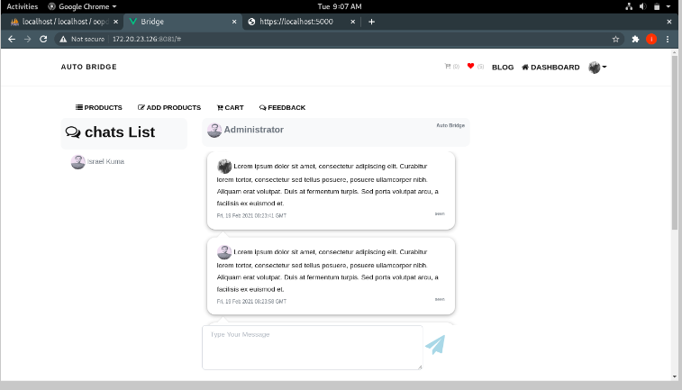

# 3.0 features to be Tested

## 3.1 Functional Test

During functional testing the test team use preloaded data to search the spare parts. And we can manage to see the searched spare parts along with the year of make, manufacturing company and price.

During registration we can manage to register the dealers and also, we can insert /encode the data after the registration is successful. And we have tried all the functions we expected in the software requirement document.

So functionally the platform is functional according to the specification and design documents

## 3.2 Authentication

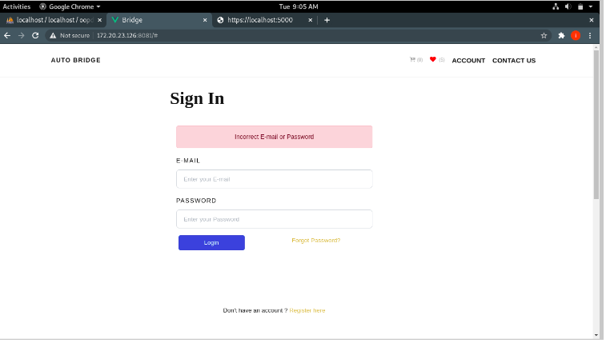

## 3.3 searching Dealers result

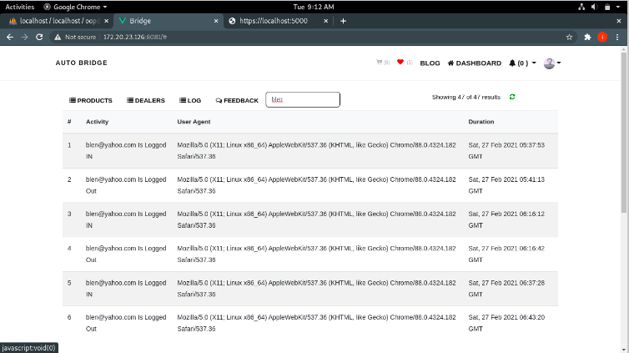

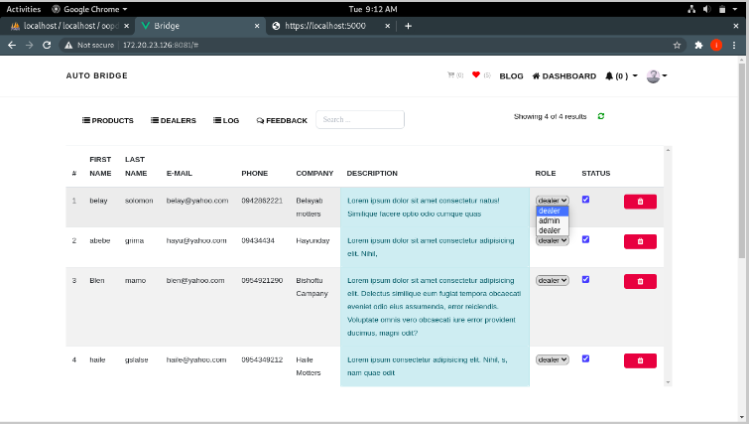

## 

## 3.4 Spare part Searching result

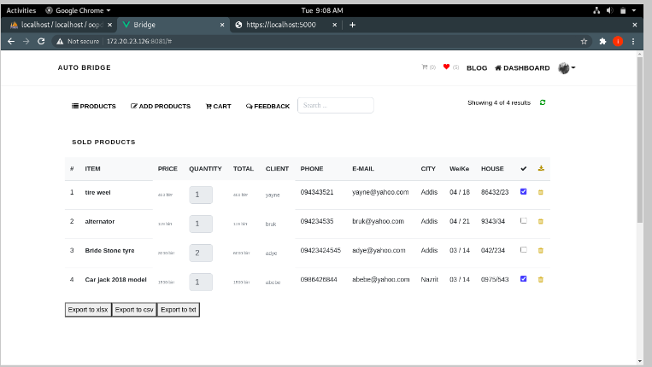

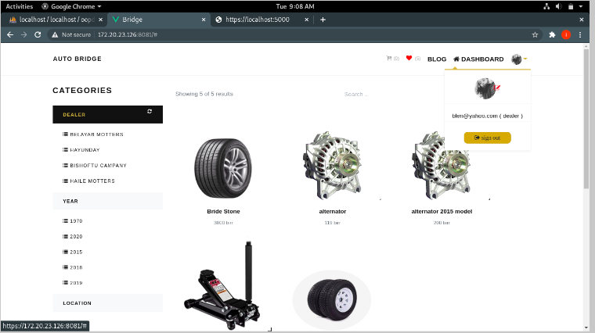

# 4.0 Features not to be tested

## 4.1 Deployment

The time period we have in testing and implementing this platform does not allow us to deploy the platform in the user’s computer and check by the clients

## 4.2 Stress handling

We cannot test the maximum stress the platform can handle. The reason is that it is not possible to deploy the system.

4.3 Users Acceptance Testing

The purpose behind user acceptance testing is to conform that system is developed according to the specified user requirements and is ready for operational use. And this test should be done by the client but due to the above constraints we cannot do the test

# 5 Testing Strategy

We have used an agile method of testing the platform. Each week we meet and test the functionality and we added additional features to be included that satisfies the need of the customers.

According to the specification and designing document the design team codes the program and at the end of the week the rest of the team checks the functionality.

# 6 Test case specification

## 6.1 Dealers registration test case

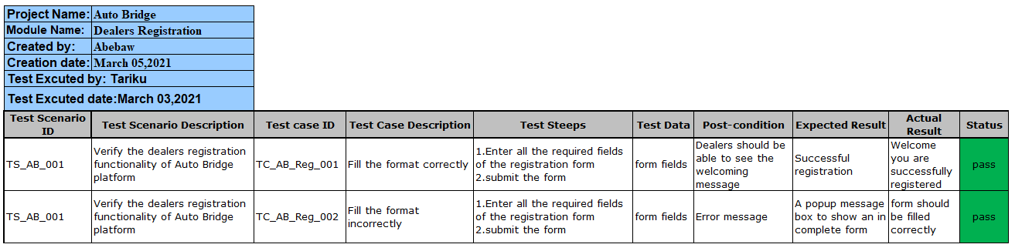

## 6.2 Dealers login test case

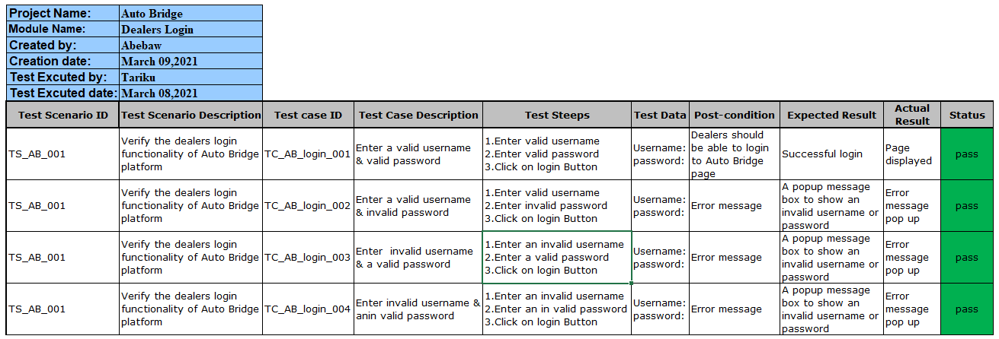

## 6.3 users searching of item test case

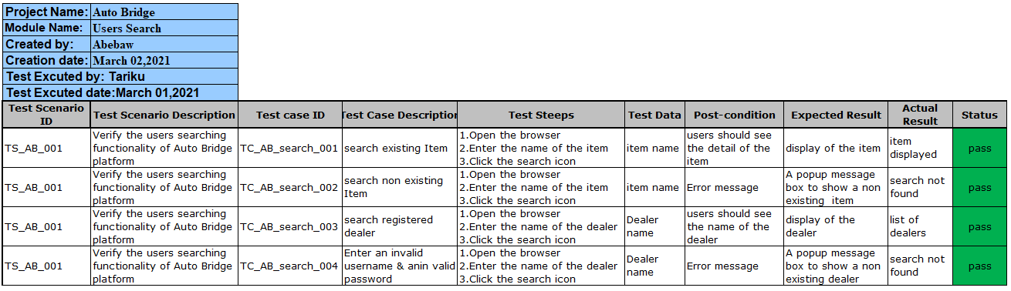

References

1. Sommer vile 10th edition
2. IEEE standard 829-1983 format